FRESHSCAN AI
AI-Based Fruit and Vegetable Freshness Detection System

1. INTRODUCTION
1.1 Project Overview
FreshScan AI is a web-based intelligent application developed to detect the freshness of fruits and vegetables using deep learning and computer vision techniques. The system allows users to upload an image of a fruit or vegetable through a web interface, after which the application analyzes the image and determines whether the item is fresh or rotten.
The project uses a pre-trained deep learning model based on the VGG16 convolutional neural network architecture, implemented using TensorFlow and Keras. The backend of the application is built using the Flask web framework, while the frontend is designed using Bootstrap 5 with a modern glassmorphic user interface. The system currently supports fourteen different fruits and vegetables, each classified into two states—fresh and rotten—resulting in a total of twenty-eight output categories.
FreshScan AI is designed to be deployed on cloud platforms such as Heroku, making it easily accessible and suitable for real-world applications in agriculture, grocery stores, and food quality inspection systems.

1.2 Purpose
The primary purpose of FreshScan AI is to automate the process of detecting fruit and vegetable freshness using artificial intelligence. Manual inspection methods are often inconsistent, time-consuming, and dependent on human judgment. This project aims to replace such traditional methods with a reliable, fast, and objective system.
By providing instant freshness classification along with confidence scores, FreshScan AI helps users make informed decisions regarding the quality of produce. The system also aims to reduce food wastage, improve supply chain efficiency, and support digital transformation in agricultural and retail industries.

2. IDEATION PHASE
2.1 Problem Statement
In the current agricultural and retail ecosystem, a large percentage of fruits and vegetables are wasted due to improper freshness evaluation. Vendors and consumers rely mostly on visual inspection, which varies from person to person and often fails to detect early spoilage.
There is no simple, affordable, and automated system available that can accurately classify produce freshness using just an image. This lack of automation results in economic losses, reduced consumer trust, and increased food waste. FreshScan AI addresses this problem by providing an AI-based freshness detection system that works through a simple web interface.

2.2 Empathy Map Canvas
From the perspective of farmers, vendors, and consumers, freshness detection is a major concern. Users often think, “Is this fruit really fresh or already spoiled?” They see produce that looks fine externally but may already be rotten. This creates confusion and doubt.
Users feel frustrated when they purchase spoiled fruits or vegetables unknowingly. They express dissatisfaction and loss of trust in sellers. To avoid this, they either manually inspect items repeatedly or discard produce unnecessarily. The major pain points include lack of transparency, inconsistent quality checks, and absence of technological assistance. FreshScan AI provides clarity, confidence, and peace of mind through AI-based analysis.

2.3 Brainstorming
During the brainstorming phase, multiple ideas were explored to solve the freshness detection problem. These included sensor-based systems, chemical analysis, and manual grading tools. However, image-based deep learning was chosen as the most practical and scalable solution.
The final idea focused on building a web-based platform where users could upload images and instantly receive freshness predictions. Additional ideas included confidence score display, modern UI design, and cloud deployment for accessibility.

3. REQUIREMENT ANALYSIS
3.1 Customer Journey Map
The user journey begins when the user accesses the FreshScan AI web application. The user uploads an image of a fruit or vegetable using the provided interface. Once the image is submitted, the system processes it in the backend and performs prediction using the trained deep learning model.
After analysis, the system displays the predicted freshness status along with a confidence score. The user can then decide whether the produce is suitable for consumption or sale. This seamless journey ensures minimal effort and maximum clarity for the user.

3.2 Solution Requirements
Functional Requirements
The system must allow users to upload images of fruits and vegetables. It should preprocess the uploaded image, perform prediction using the trained model, and display the result clearly. The system should support multiple fruit and vegetable categories and provide confidence scores for predictions.
Non-Functional Requirements
The application must be responsive, secure, and fast. It should handle image uploads efficiently and provide accurate predictions within a short time. The user interface must be intuitive and visually appealing. The system should be scalable and suitable for cloud deployment.

3.3 Data Flow Diagram
At the highest level, the data flow starts with the user uploading an image through the web interface. The image is sent to the Flask backend, where preprocessing is performed. The processed image is then passed to the deep learning model for prediction. The output is sent back to the frontend and displayed to the user.
At the detailed level, the process includes image validation, resizing, normalization, prediction probability calculation, and result rendering.

3.4 Technology Stack
FreshScan AI uses Flask for backend development, TensorFlow and Keras for deep learning, VGG16 for feature extraction, NumPy and Pillow for image processing, and Bootstrap 5 for frontend design.
Technically, this app uses:

Flask - Web framework
TensorFlow - AI library
Keras - Deep learning
VGG16 - Pre-trained AI model
Bootstrap 5 - Beautiful design
NumPy & Pillow - Image processing

4. PROJECT DESIGN
4.1 Problem–Solution Fit
FreshScan AI effectively addresses the problem of manual freshness detection by introducing an automated, AI-based solution. The use of deep learning ensures high accuracy, while the web-based interface ensures ease of use. The solution fits well within the agricultural and retail domains where fast decision-making is essential.

4.2 Proposed Solution
The proposed solution is a web application that integrates a trained deep learning model with a Flask backend. Users upload images, and the system classifies the produce into fresh or rotten categories. The confidence score enhances transparency and trust in the prediction.

4.3 Solution Architecture
The system follows a client-server architecture. The client side consists of a Bootstrap-based web interface, while the server side handles image processing and prediction. The deep learning model operates as a core component within the backend.
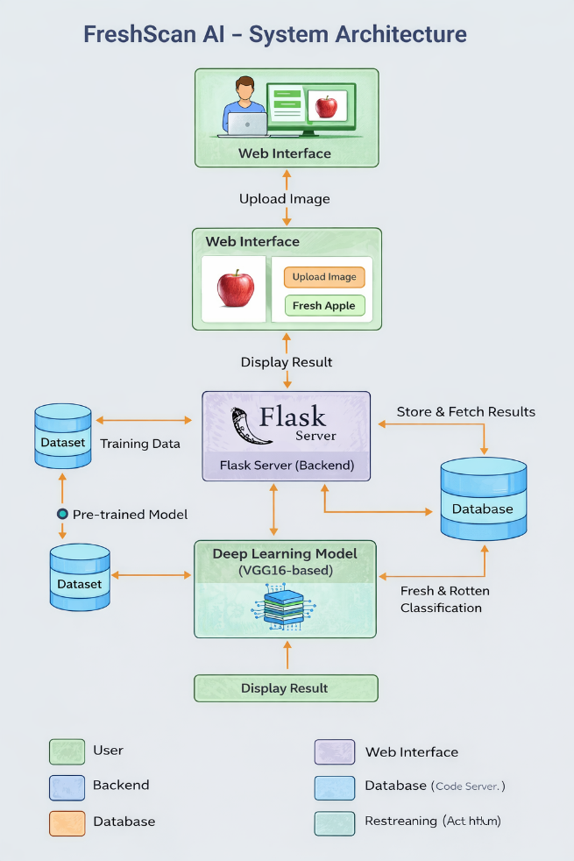

5. PROJECT PLANNING & SCHEDULING
The project was planned in phases starting from requirement analysis and dataset preparation to model training, web development, testing, and deployment. Each phase was executed sequentially to ensure proper integration and functionality.

6. FUNCTIONAL AND PERFORMANCE TESTING
The system was tested for correct image upload handling, accurate prediction generation, and proper result display. Performance testing ensured that predictions are generated quickly and that the system can handle multiple requests efficiently.

7. RESULTS
The application successfully classifies fruits and vegetables into fresh and rotten categories. The output screen displays the predicted class along with a confidence score, making the result easy to understand for users.

8. ADVANTAGES & DISADVANTAGES
FreshScan AI provides fast, consistent, and accurate freshness detection. It reduces dependency on manual inspection and helps minimize food wastage. However, the system depends on image quality and cannot detect internal spoilage.

9. CONCLUSION
FreshScan AI demonstrates the effective use of deep learning and web technologies to solve a real-world problem. The project successfully integrates AI with a user-friendly web application, providing a practical solution for freshness detection.

10. FUTURE SCOPE
Future enhancements may include mobile application development, real-time camera-based detection, support for additional produce types, and integration with IoT devices for smart agriculture.

11. APPENDIX
The complete source code, trained model files, and deployment configuration are available in the project repository.
Demo link: https://drive.google.com/file/d/1dOLly50NKKdNrVJ_IuX99t3voAtWTQ9/view?usp=sharing

GitHub Link:
https://github.com/BalusuSamhitha/FreshScanAI.git

